Loading a Property SQL Database File
Contents
Version History 2
Overview 2
Downloading Data Files 2
Loading SQL Data Files in SQL Server Express 2

Version History
Version | Date | What
2.0 | 2012-07-20
3.0 | 2019-01-23 | Updated to reflect current files and version.

Overview
This document is intended to assist a general consumer of the property SQL data files in loading the data files into Microsoft SQL Server or Microsoft SQL Server Express. The descriptions in this document assume a certain level of general familiarity with normal Windows navigation and basic skills of navigating to websites, downloading files, installing and launching software, etc. The overall process of using these database files may be difficult for even some experienced computer users.

Downloading Data Files
The SQL database files can be downloaded from the Montana State Library FTP. Once you have selected the county of your choice (or the statewide file) and downloaded the file, you’ll need to extract the Output.mdf file within the zip file. If you don’t have a 3rd party software to unzip files, you can use Windows’ built-in tools by double clicking the downloaded zip file, selecting the Output.mdf file and then selecting “Extract all files”.
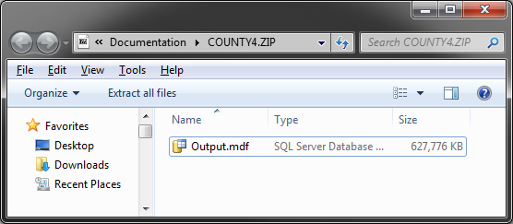
**NOTE: As of the writing of this document, if you are using SQL Server Express (free version) you will not be able to load the statewide SQL data file as the database size exceeds the maximum allowed size for SQL Server Express (10 GB). If this is the case, you will need to individually download and open the SQL data files for the specific counties you are interested in.

Loading SQL Data Files in SQL Server Express
To load the SQL data file(s), you’ll need to open Microsoft SQL Server Management Studio (SSMS). If you do not yet have it installed, you’ll need to download the latest version from Microsoft and install it. Once you have SSMS installed, you’ll need to connect to your local instance of SQL. You should be able to connect by typing “localhost” in the Server Name field.
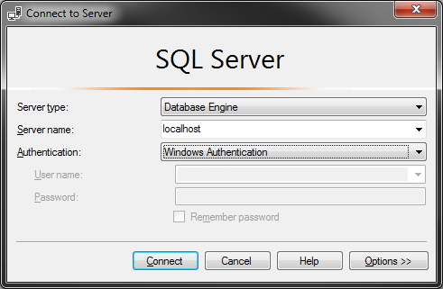
Once you are connected to your local instance, you’ll need to attach the database. You do this by right clicking on “Databases” in the Object Explorer and selecting “Attach…”. You then “Add…” a database to attach which will allow to you browse to the location you saved your SQL data file. By default it will attach as a database named “Output”. If you’d like to customize this for a specific county, you can change the name in the “Attach As” field.
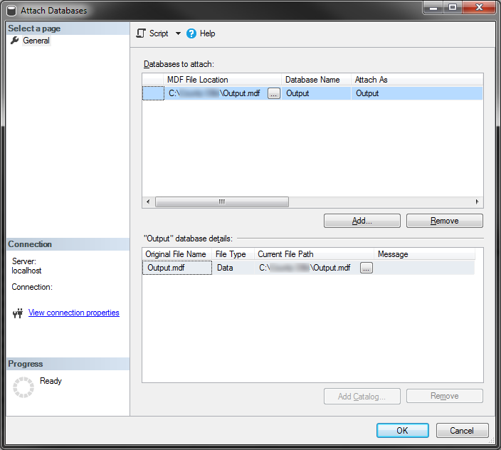
If you get an error message that looks like the following, it is because you need to use the most recent version of SQL Server or SQL Server Express and your current version is too old to load the SQL data file.


